DATA MANAGEMENT SYSTEM

2 DMS PROJECT PHASE – I SPECIFICATIONS
2.1 Graphical User Interface

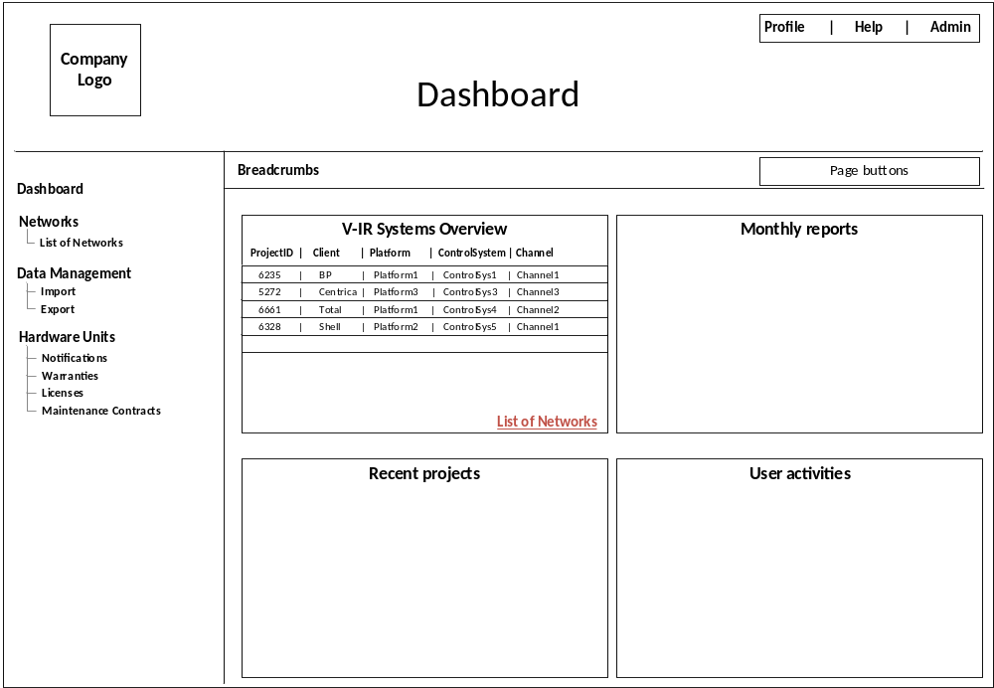
Figure 1: Page – 2 wireframe dashboard page

Dashboard Page;
- Only the column ‘Channel’ should be hyperlinked, on mouse over column content should show underline, and on mouse click should go to “Network Image” page or “Graph” page.

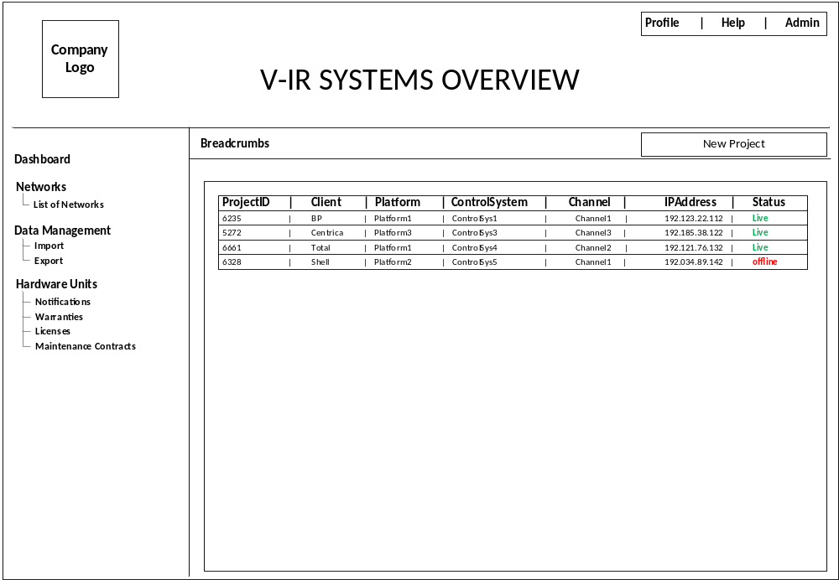
Figure 2: Page – 3, wireframe, list of networks

List of Networks page,
- Only the column ‘Channel’ should be hyperlinked, on mouse over column content should show underline, and on mouse click should go to “Network Image” page or “Graph” page.

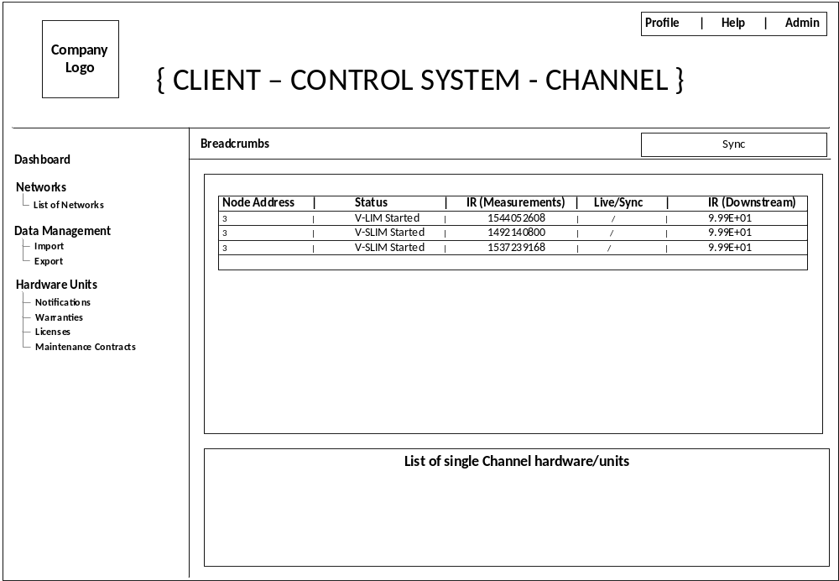
Figure 3: Page – 4, wireframe, list of network Image

Network Image page;
- Remove Project ID column
- Table should restrict and show only last record of node:1, node:2 and node:3, if the network contains 3 nodes in total. (for exam: one main unit and two sub units)

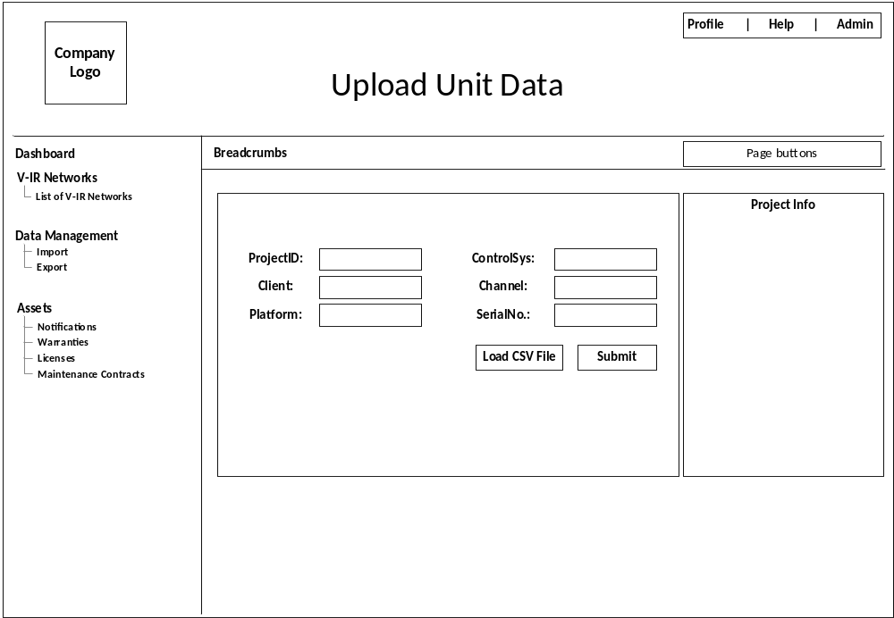
Figure 4: Page – 6, wireframe, Upload Unit Data Image

Upload Unit Data page;
- ProjectID, Client, Platform, ControlSys, Channel, SerialNo., shall have drop down box with prefilled data from the database.
- Replace the name ‘upload’ to ‘Load CSV File’
- Based on the selection, the complete CSV data shall upload it to the database ‘product_data’ table.

network_unit table;
project_id | channel | company_name | control_system | ip_address | is_alive | platform | unit_serial_no | unit_config_id
'5272' | 'ChannelB' | 'Centrica' | 'ControlSys2' | '11.106.30.59' | '0' | 'Test' | '321297' | '2'
'6235' | 'ChannelA' | 'BP' | 'ControlSys1' | '10.106.30.59' | '0' | 'Test' | '121297' | '1'
'6328' | 'Channel4' | 'Shell' | 'ControlSys_F' | '13.106.30.59' | '0' | 'Test' | '521297' | '4'
'6661' | 'ChannelC' | 'Total' | 'ControlSys3' | '12.106.30.59' | '0' | 'Test' | '421297' | '3'

In this ‘network_unit’ table;
- ‘project_id’ remains same and remove the primary key
- Introduce ‘project_info_id’ will be unique and also the primary key

Project_info_id | project_id | channel | company_name | control_system | ip_address | is_alive | platform | unit_serial_no | unit_config_id
01 | '5272' | 'ChannelB' | 'Centrica' | 'ControlSys2' | '11.106.30.59' | '0' | 'Test' | '321297' | '2'
02 | '6235' | 'ChannelA' | 'BP' | 'ControlSys1' | '10.106.30.59' | '0' | 'Test' | '121297' | '1'
03 | '6328' | 'Channel4' | 'Shell' | 'ControlSys_F' | '13.106.30.59' | '0' | 'Test' | '521297' | '4'
04 | '6661' | 'ChannelC' | 'Total' | 'ControlSys3' | '12.106.30.59' | '0' | 'Test' | '421297' | '3'

The ‘project_id’ cannot assign to primary key, same project ID shall be assigned to different platform, control system, and channel. The network scenario diagram is shown below.

product_data table;
Id | lim_capacitance | lim_capacitance_cm | lim_imbalance | lim_resistance | lim_resistance_cm | line_current | line_frequency | line_phase | line_voltage | status | time | type | vNetAddress | unit_project_id
'1' | '123' | '123' | '12' | '12' | '12' | '12' | '12' | '12' | '12' | 'V-LIM Started' | '2014-10-24T10:26:31' | '2' | '1' | '6235'
'2' | '123' | '123' | '12' | '24' | '12' | '12' | '12' | '12' | '12' | 0x0 | '2014-11-24T10:26:31' | '2' | '2' | '6235'
'3' | '123' | '123' | '12' | '12' | '12' | '12' | '12' | '12' | '12' | 'V-LIM Started' | '2014-10-24T10:26:31' | '2' | '1' | '5272'
'4' | '123' | '123' | '12' | '24' | '12' | '12' | '12' | '12' | '12' | 0x0 | '2014-11-24T10:26:31' | '2' | '2' | '5272'
'5' | '123' | '123' | '12' | '36' | '12' | '12' | '12' | '12' | '12' | 0x0 | '2014-12-24T10:26:31' | '2' | '3' | '5272'
'6' | '123' | '123' | '12' | '12' | '12' | '12' | '12' | '12' | '12' | 'V-LIM Started' | '2014-10-24T10:26:31' | '2' | '1' | '6661'
'7' | '123' | '123' | '12' | '0' | '12' | '12' | '12' | '12' | '12' | 'V-LIM Started' | '2014-10-24T10:26:31' | '2' | '1' | '6328'
'8' | '123' | '123' | '12' | '12' | '12' | '12' | '12' | '12' | '12' | 0x0 | '2014-11-24T10:26:31' | '2' | '2' | '6328'
'9' | '123' | '123' | '12' | '24' | '12' | '12' | '12' | '12' | '12' | 0x0 | '2014-12-24T10:26:31' | '2' | '3' | '6328'
'10' | '123' | '123' | '12' | '24' | '12' | '12' | '12' | '12' | '12' | 0x0 | '2015-01-24T10:26:31' | '2' | '4' | '6328'
'11' | '123' | '123' | '12' | '36' | '12' | '12' | '12' | '12' | '12' | 0x0 | '2015-02-24T10:26:31' | '2' | '5' | '6328'

In this ‘product_data’ table;
- Replace ‘unit_project_id’ to ‘project_info_id’
Network Scenario:
